

**COMP 1640**

**Enterprise Web Application Development**

**Individual Report**

**P.D.A.L. Wickramasinghe - 001074749**

Table of Contents

1 Evaluation of the process and the product 3

1.1 Evaluation of the Process 3

1.1.1 Agile Roles and Responsibilities 3

1.1.2 SDLC Models 4

1.1.3 Agile Methodology 4

1.1.4 Advantages of Agile comparing to other SDLC models 5

1.2 Evaluation of the Product 6

2 Team Member Evaluation 12

3 Self-Evaluation 14

3.1 What I did 14

3.1.1 ER Diagram 15

3.1.2 Normalization 16

3.1.3 Use Case Diagram 17

3.2 What I learnt 18

# Evaluation of the process and the product

## Evaluation of the Process

We have used SCRUM which is one of the Agile techniques to accomplish this task. As the requirements we needed to take responsibilities of one role of Agile team. There were 6 major roles in Agile Scrum to play.

### Agile Roles and Responsibilities

**Product owner** - Act as the customer representative. According to our coursework there was no real customer. Therefore, Product Owner is the member who read course work firstly and identified the main fact as user stories. He is also designed he product backlog after discussing user stories deeply with Scrum team.

**Scrum master** - Scrum master is the person who has main responsibility of scrum flow. He is encouraged the scrum team to complete their tasks on time and always keep an eye on the remaining works of product backlog.

**UI designer** - UI designing part is the main responsibility of UI designer. UI designer should prepare Use case diagram and then he should identify main windows required to accomplish the customer requirements and design eye catching user interfaces.

**Database administrator**- Database administrator is the person who has the responsibility to design the database structure. He should identify the flow of data by observing the course work. Then creates the ER diagram and creates the database.

**QA coordinator** - QA coordinator has to make sure the system is working properly by identifying bugs and errors using testing methodologies. Mainly he should create test plan, test cases and parallel with testing he should prepare a test log.

**Developer** - Developer is playing major role in the process of completing the task. He should implement the logic and the working software product.

There are so many software development models in industry. Some of them are outdated and some are most popular in these days’ businesses.

### SDLC Models

* Waterfall Model
* Spiral Model
* Incremental Model
* Evolutionary Development Model
* Agile Software Development Model
* Rapid Prototyping Model

Agile is the most famous SDLC model among above models and in the software industry it is one of the most effective model to develop a high quality software. Therefore, in our course work we used Agile techniques to complete our software product and to make it succeeded. There are several most attractive and effective methodologies in Agile SDLC model.

### Agile Methodology

Before explaining the agile methodology, I would like to explain the special words related Agile which I learnt by doing this project.

**User stories -**

customer requirements in his/her own words. We didn’t have real customer. So we took the user stories details from the course work specification.

**Product owner -**

customer representative in the company. We had one of our member as product owner

**Product backlog-**

Technical document which creates by the product owner using user stories

**Sprint -**

predefined period of time to complete specified set of tasks. In our project we considered one week as a sprint.

**Sprint backlog -**

The document which is created by containing set of tasks taken by product backlog

The most important thing what I can learnt from Agile is get together once in every sprint and discuss what we have done during the previous sprint and what we have to do during the next sprint. In industrial level, they use another type of meeting called ‘Daily scrum meeting’ to discuss what scrum team has done by previous day.

There is no leader or manager in scrum team. There is only one person who led the process to the success called ‘Scrum Master’. Scrum master is also a member of Scrum team.

Not like other SDLC models, scrum team has all the authority to decide how much time we should spent for complete the given task. Then we calculated the estimated time and made same weighted portions and one should complete within the sprint.

By observing burn down charts we could get an idea how is the process moving forward. If we are running out of time during the sprint we can work much faster to complete our project.

Developments and quality assurance are parallel doing in Agile. Therefore, if we could find any error or bug we can move that item to the next sprint to correct.

### Advantages of Agile comparing to other SDLC models

* By following Agile techniques, we can deliver working software product as versions of software to the customer. It has huge impact on customer satisfaction.
* We can change our tasks as the customer requirement easily.
* If there is a bug in one item it is easy to identify it and correct it during the next sprint.
* Workflow is monitored and continuously running until the goal achieved.

## Evaluation of the Product

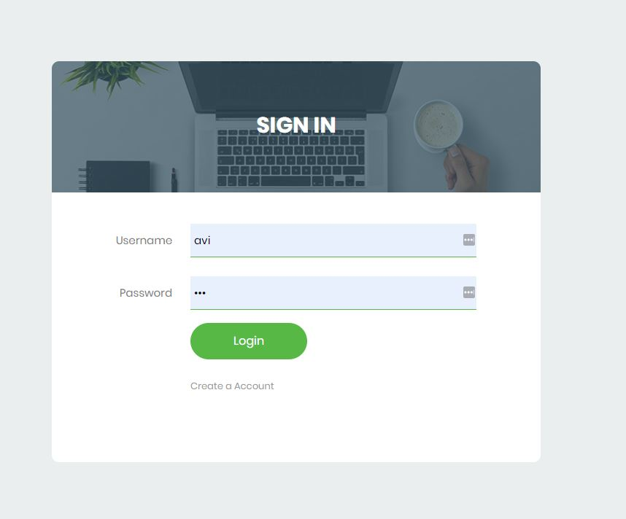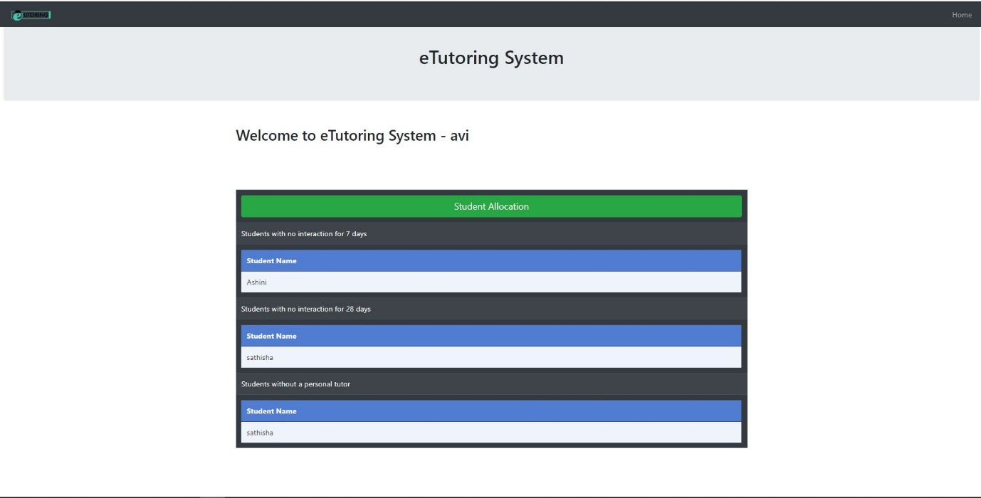

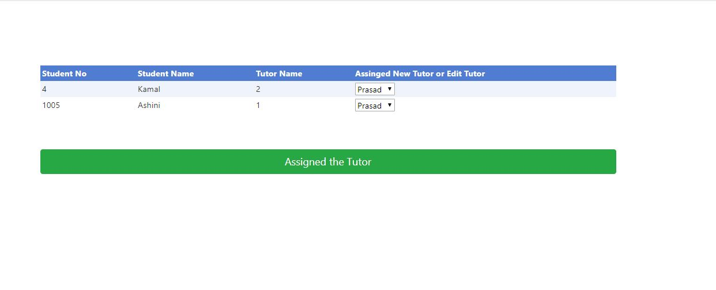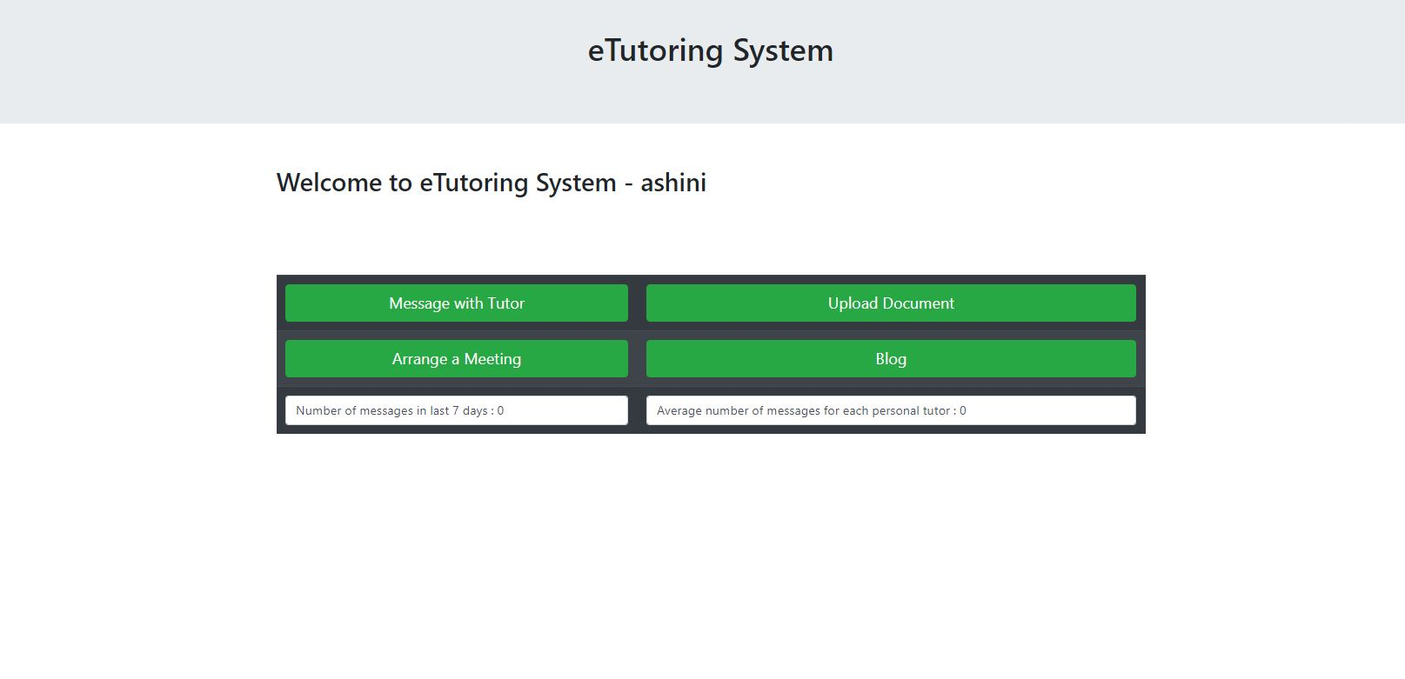

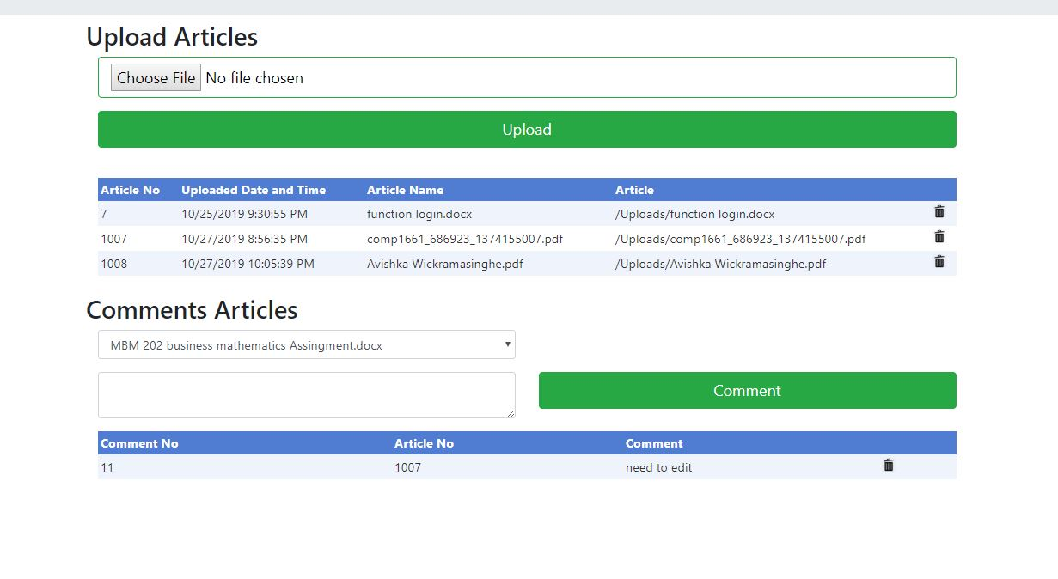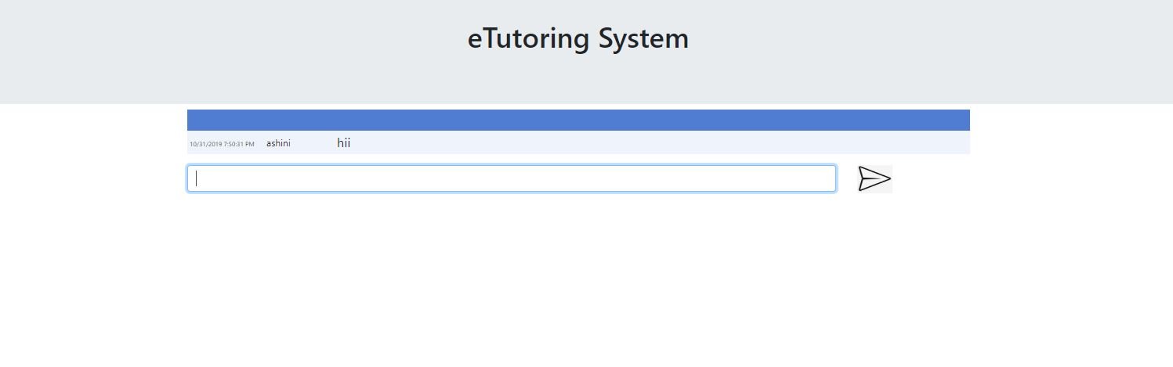

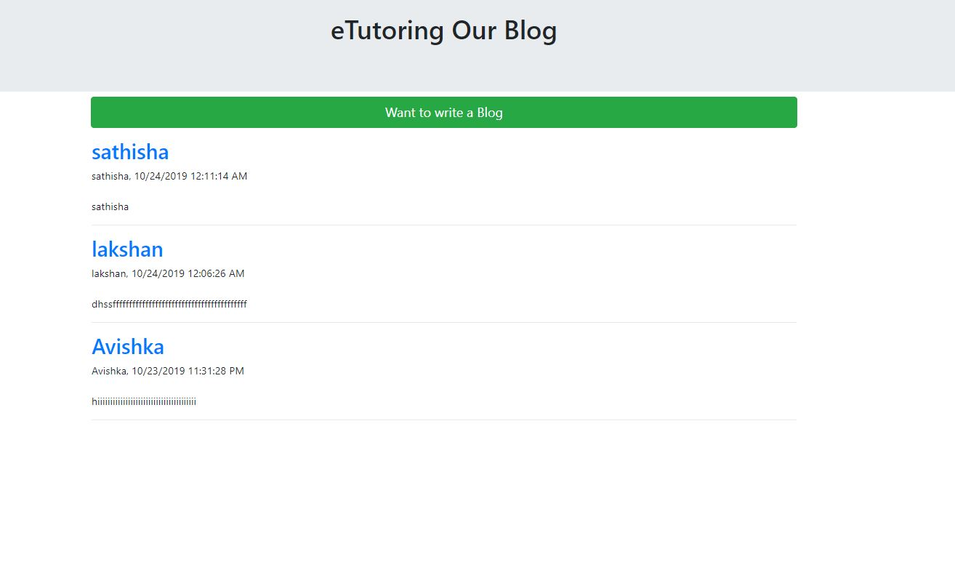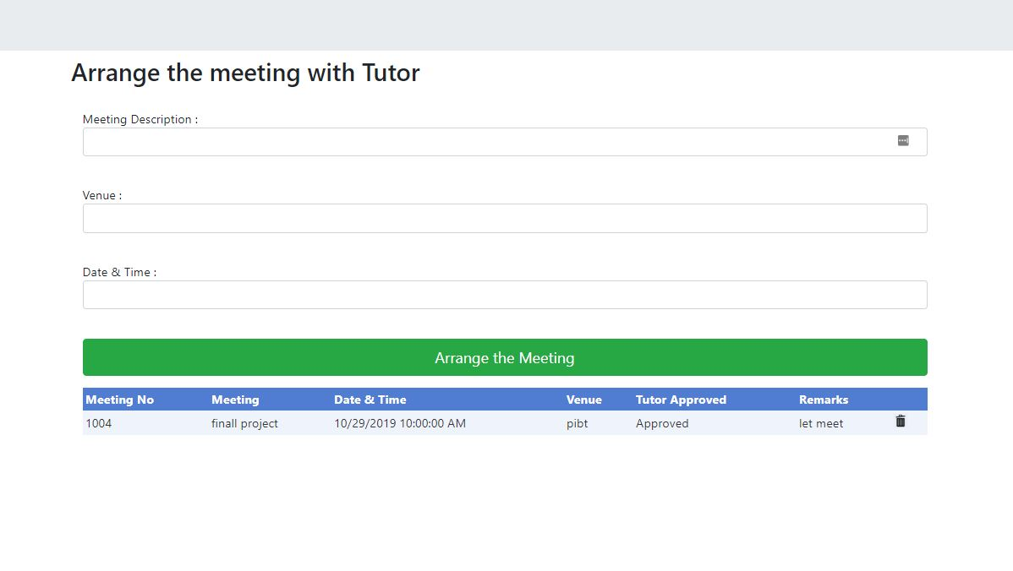

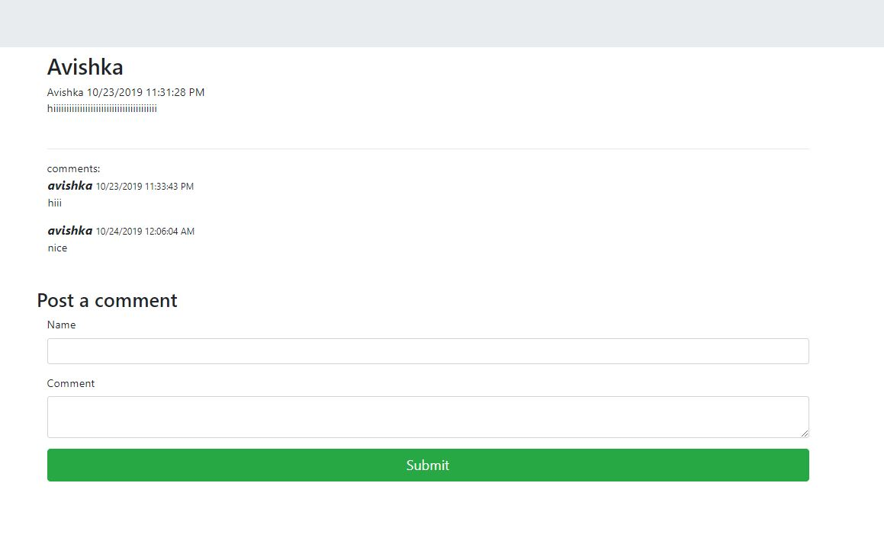

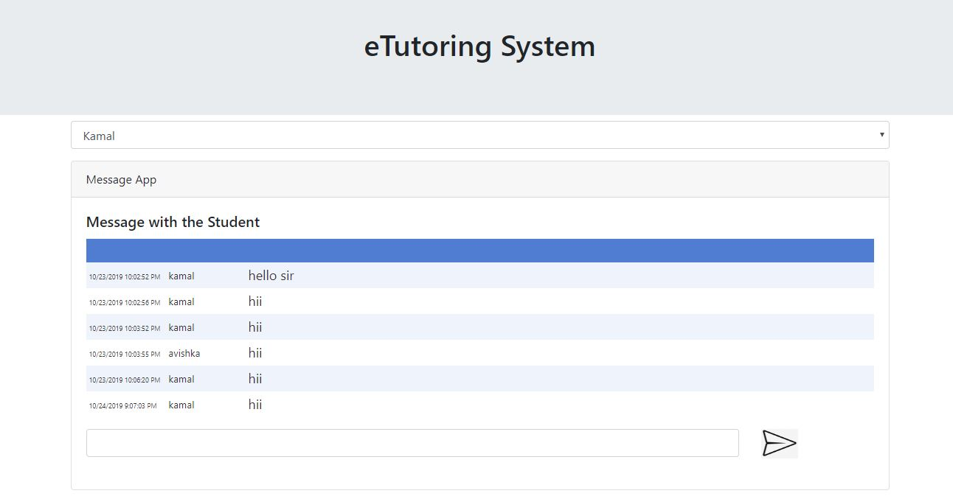

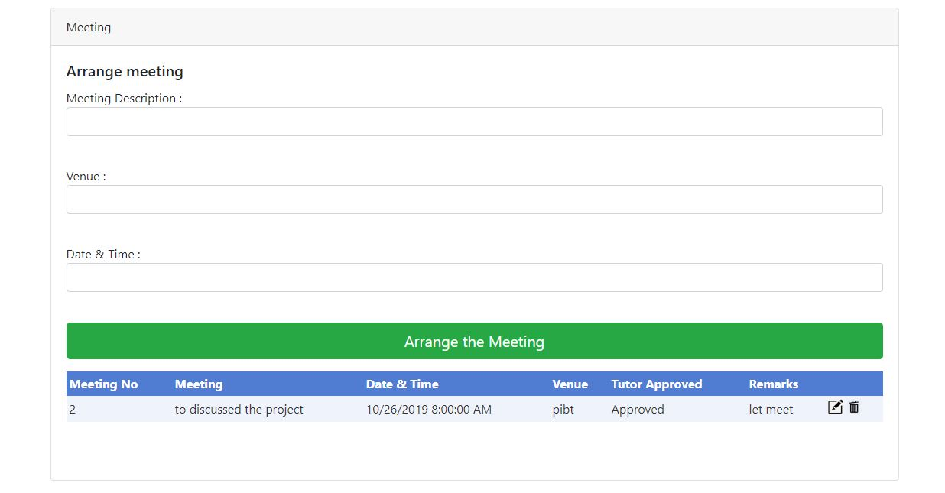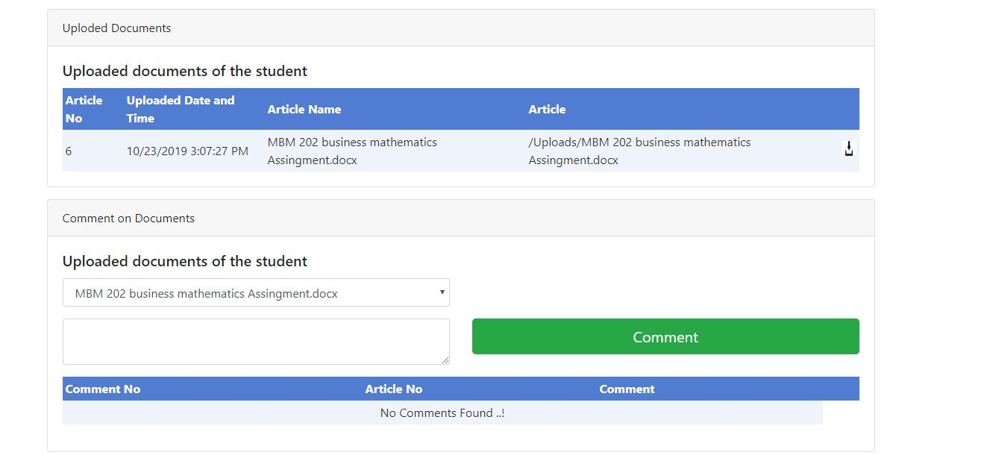

# Team Member Evaluation

|  |  |
| --- | --- |
| Weight Factor | |
| Work | |
| * Punctuality | 7 |
| * Completeness | 8 |
| * Accuracy | 8 |
| Performance as a Team Member | |
| * Responding to the communication | 6 |
| * Collaboration | 7 |
| * Physical Attendance | 9 |

|  |  |  |  |  |  |
| --- | --- | --- | --- | --- | --- |
| **Criteria** | **Weight Factor** | **Team Members** | | | |
|  |  | **Avishka** | | **Savani** | |
| **Work** |  | **Weight** |  | **Weight** |  |
| **Punctuality** | 7 | 6 | 42 | 6 | 42 |
| **Completeness** | 8 | 7 | 56 | 7 | 56 |
| **Accuracy** | 8 | 8 | 64 | 6 | 48 |
| **Total** |  |  | 162 |  | 146 |
| **Percentage** |  |  | 91.53% |  | 82.48% |
|  |  |  |  |  |  |
| **Performance as a Team Member** |  |  |  |  |  |
| **Responding to the**  **Communication** | 6 | 5 | 30 | 5 | 30 |
| **Collaboration** | 7 | 6 | 42 | 6 | 42 |
| **Physical Attendance** | 9 | 8 | 72 | 8 | 72 |
| **Total** |  |  | 144 |  | 144 |
| **Percentage** |  |  | 86.74% |  | 86.74% |

# Self-Evaluation

## What I did

I have played several roles to achieve this task and make the project succeeded. Developer was my main role and also I took the responsibilities of Database administrator. Also I have contributed my effort as the UI designer’s responsibilities.

Developer

I played the major role as the Developer. I had to create the full application with my previous knowledge and experiences of developing systems but this was most critical think to do, since this is considerably huge project. My main considerations were How to delepoded the program with less bugs and user friendly manner to the user. Finally, I create the application with my full effort to full fill the requirements.

Database Administrator

I played the role as the Database Administrator. I had to create ER Diagram with my previous knowledge and experiences of designing ER diagrams but this was most critical think to do, since this is considerably huge project. My main considerations were How to store all the data without data redundancy, what are the tables and fields I should create, what kind of relationships should I create among the tables etc. finally I could create normalized database tables by applying first, second and third normalization forms.

UI Designer

I had to do the UI designer role also. I created a Use case diagram, and developed the all frontend designs.

### ER Diagram

### er

### Normalization

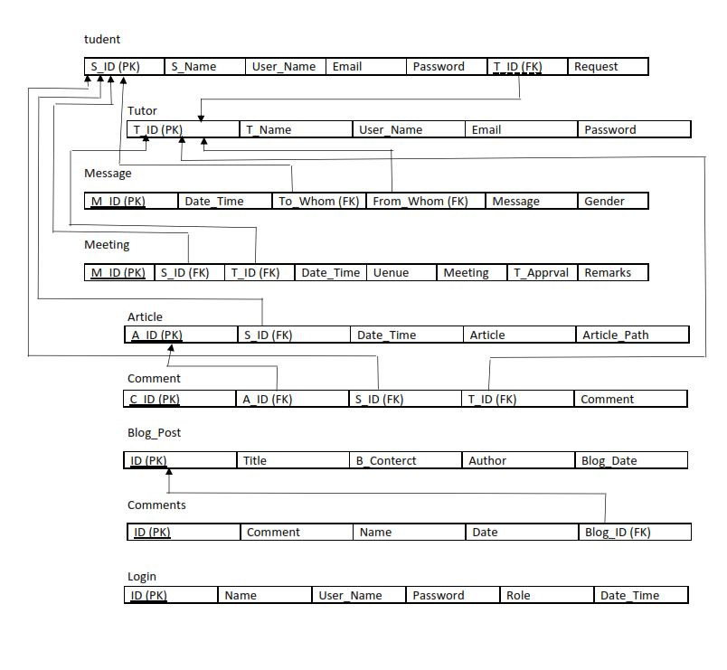

### Use Case Diagram

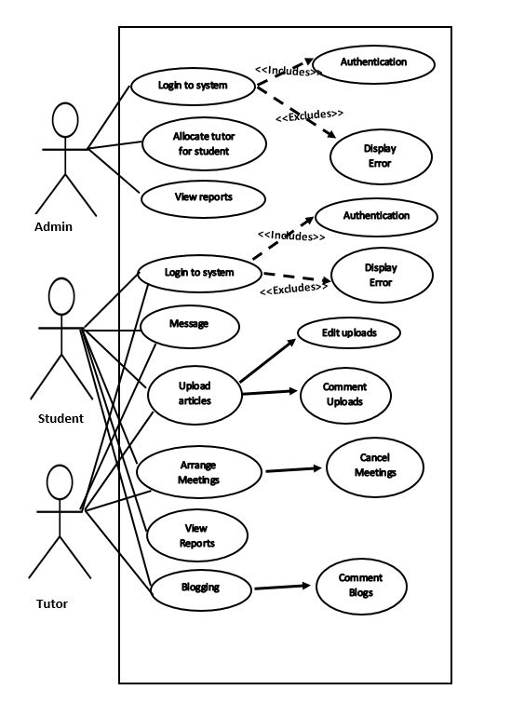

## What I learnt

* I never had an experience as developer in a huge project like this and with this project I got an idea how to make a project success.
* The value of team spirit
* How to manage limited time to achieve goal